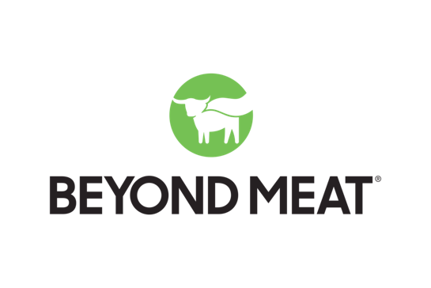

Beyond Meat strengths
- Brand awareness:
  - In 2023, Beyond Meat is ranked #2 in terms of brand awareness for a meat substitute (Morningstar Farms is #1 and Impossible is #3, but all are neck-and-neck for the top spot, per a Statista report).
- Brand partnerships:
  - Beyond Meat currently partners with other brands such as the fast-food chain Carl’s Jr.
  - The company has also partnered with Kim Kardashian, who is known as Beyond Meat’s Chief Taste Consultant.
- Environmentalism:
  - As a meat substitute, Beyond Meat is able to appeal to environmentalists by encouraging consumers to go meatless.

Beyond Meat weaknesses
- Social media presence
  - The brand’s social media posts on Instagram and TikTok have very low engagement, aside from the occasional viral video.
  - Beyond Meat does not often interact with its followers on social media, thus contributing to less engagement.
- Cost:
  - Beyond Meat products are typically more expensive than regular meat, as reported by Time magazine.

Beyond Meat opportunities
- New partnerships with creators
  - Beyond Meat has the opportunity to reach a wider audience by launching new partnerships with social media influencers, video creators, chefs, and more.
- More moves toward sustainability, environmentalism, veganism/plant-based diets
  - As the world moves toward more sustainable, plant-based food choices that support the vegan and environmentalist movements, Beyond Meat has the opportunity to attract more customers who want to steer away from traditional meat-filled meals.

Beyond Meat threats
- Other meat alternative brands: Impossible, Morningstar Farms, Gardein, Amy’s Kitchen
  - Beyond Meat currently competes against other well-known meat alternatives as well as up-and-coming brands.
- The fall of plant-based meat
  - Some say that in 2024, meat alternatives like Beyond Meat will not be as favored as other plant-based meat substitutes like legumes, tofu, and tempeh. Brit + Co reports according to Whole Foods’ 2024 predictions for food trends, “fashionably fake” meats like Beyond Meat. and Impossible will fall from popularity in the coming year.
- Health concerns and criticism surrounding alternative meat products
  - Time magazine states that there is a continued rise in criticism of meat substitutes. Some claim that Beyond Meat products are unhealthy due to how processed they are and how many ingredients they contain. Time also reports that the science beyond the health benefits of Beyond Meat products is “fuzzy” and it is inconclusive whether a Beyond Burger is healthier than a traditional beef burger.

